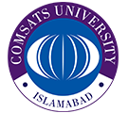**COMSATS** **University Islamabad, Lahore Campus**

**Department of Computer Science**

|  |  |  |  |  |  |  |  |  |
| --- | --- | --- | --- | --- | --- | --- | --- | --- |
| Course Title: |  | | | | Course Code: |  | Credit Hours: |  |
| Course Instructor/s: |  | | | | Program Name: | BCS | | |
| Semester: |  | Batch: |  | Section: |  | Date |  | |
| Student’s Name: |  | | | | Reg. No. |  | | |

